***Virginia Junior Classical League***

*presents this*

Certificate of Excellence

*to*

Max Wohlleben

*of*

West Potomac High School

*for*

*2nd Place in Photography*

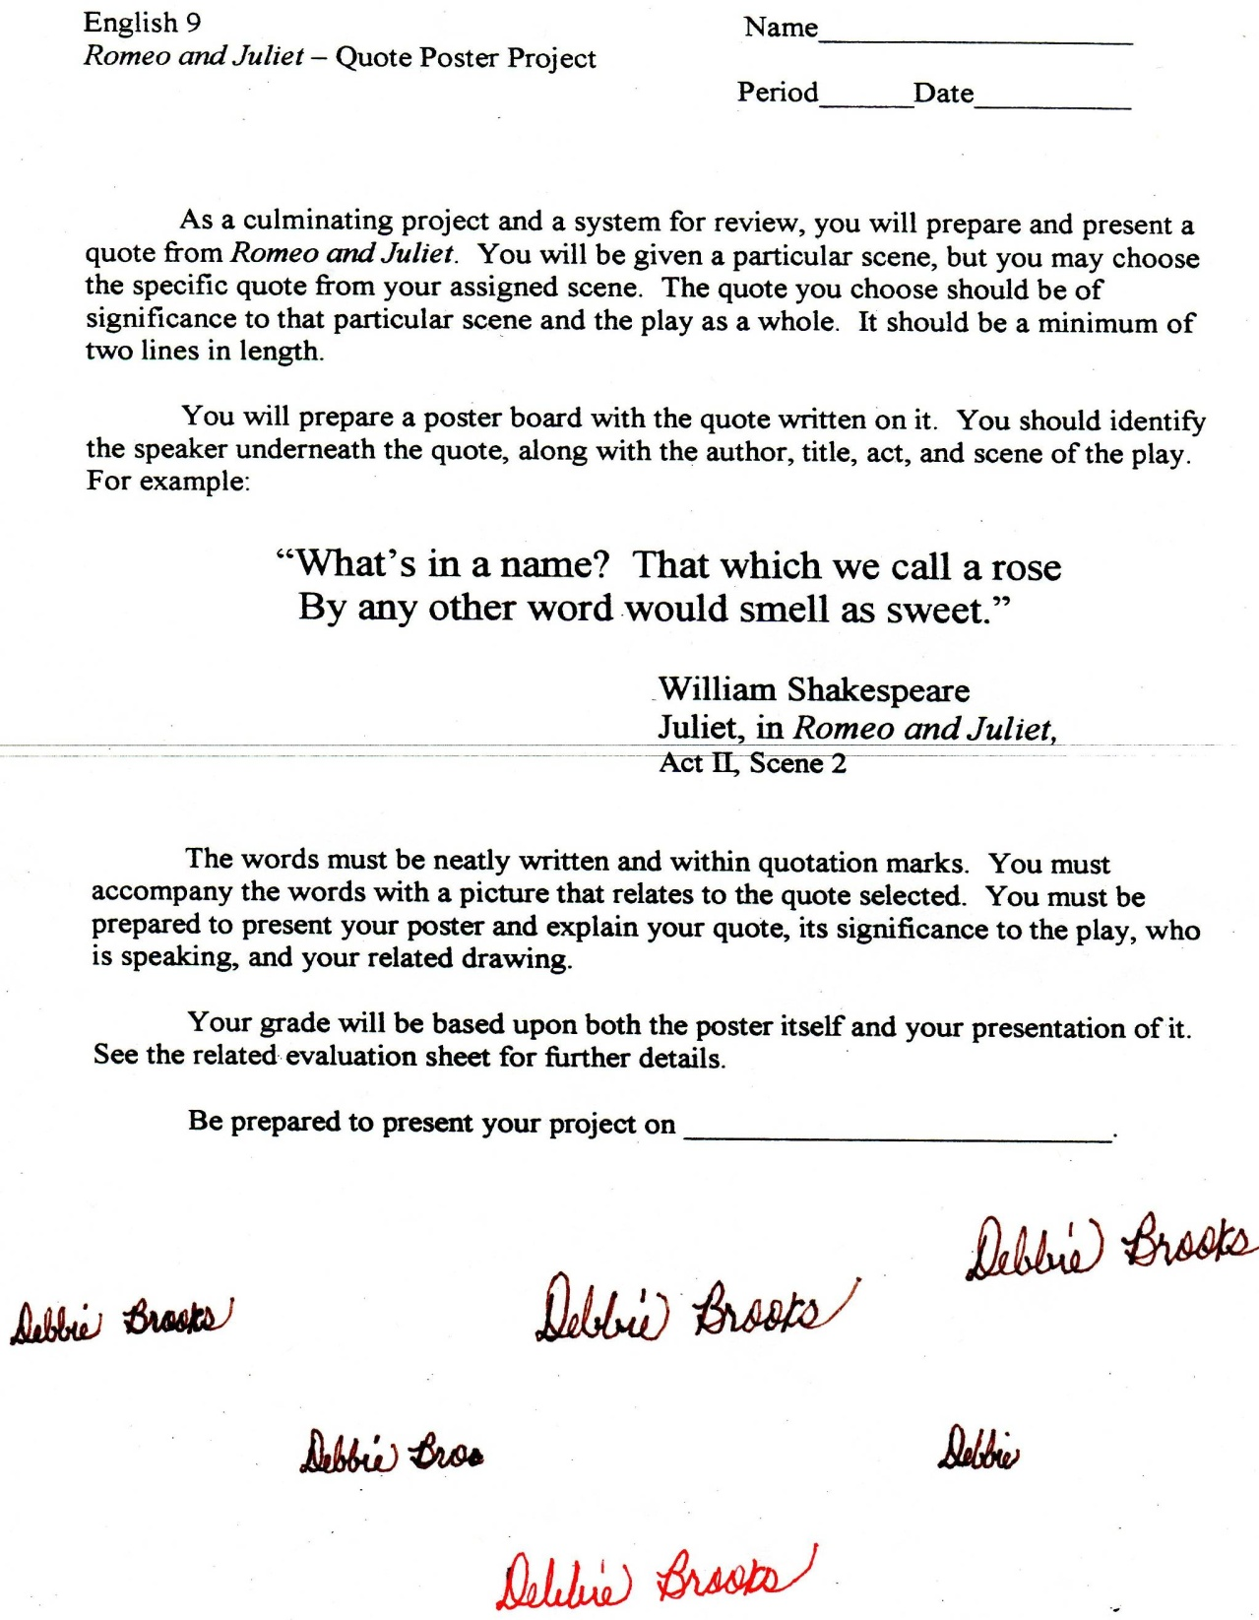

Microsoft Office Signature Line...

*a.d. viii Kal. Dec. MMDCCLXVII A.U.C. 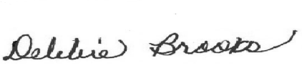*

***Virginia Junior Classical League***

*presents this*

Certificate of Excellence

*to*

Alden Wohlleben

*of*

West Potomac High School

*for*

*2nd Place in Small Models*

**

Microsoft Office Signature Line...

*a.d. viii Kal. Dec. MMDCCLXVII A.U.C. *

***Virginia Junior Classical League***

*presents this*

Certificate of Excellence

*to*

Justin Lakier

*of*

West Potomac High School

*for*

*3rd Place in Impromptu Art*

**

Microsoft Office Signature Line...

*a.d. viii Kal. Dec. MMDCCLXVII A.U.C. *

***Virginia Junior Classical League***

*presents this*

Certificate of Excellence

*to*

Jackie Amacker

*of*

West Potomac High School

*for*

*3rd Place in Ink*

**

Microsoft Office Signature Line...

*a.d. viii Kal. Dec. MMDCCLXVII A.U.C. *

***Virginia Junior Classical League***

*presents this*

Certificate of Excellence

*to*

Mick Starego

*of*

West Potomac High School

*for*

*5th Place in Latin Oratory*

**

Microsoft Office Signature Line...

*a.d. viii Kal. Dec. MMDCCLXVII A.U.C. *

***Virginia Junior Classical League***

*presents this*

Certificate of Excellence

*to*

Aurora Lewis

*of*

West Potomac High School

*for*

*5th Place in Ornaments*

**

Microsoft Office Signature Line...

*a.d. viii Kal. Dec. MMDCCLXVII A.U.C. *

***Virginia Junior Classical League***

*presents this*

Certificate of Excellence

*to*

Kevin O'Meara

*of*

West Potomac High School

*for*

*6th Place in Mosaics*

**

Microsoft Office Signature Line...

*a.d. viii Kal. Dec. MMDCCLXVII A.U.C. *

***Virginia Junior Classical League***

*presents this*

Certificate of Excellence

*to*

Claire Havranek

*of*

West Potomac High School

*for*

*7th Place in Life*

**

Microsoft Office Signature Line...

*a.d. viii Kal. Dec. MMDCCLXVII A.U.C. *

***Virginia Junior Classical League***

*presents this*

Certificate of Excellence

*to*

Mia Hancock

*of*

West Potomac High School

*for*

*7th Place in Latin Oratory*

**

Microsoft Office Signature Line...

*a.d. viii Kal. Dec. MMDCCLXVII A.U.C. *

***Virginia Junior Classical League***

*presents this*

Certificate of Excellence

*to*

Jimmy Figliola

*of*

West Potomac High School

*for*

*7th Place in Storytelling*

**

Microsoft Office Signature Line...

*a.d. viii Kal. Dec. MMDCCLXVII A.U.C. *

***Virginia Junior Classical League***

*presents this*

Certificate of Excellence

*to*

Jackie Amacker

*of*

West Potomac High School

*for*

*7th Place in Watercolor*

**

Microsoft Office Signature Line...

*a.d. viii Kal. Dec. MMDCCLXVII A.U.C. *

***Virginia Junior Classical League***

*presents this*

Certificate of Excellence

*to*

Jackie Amacker

*of*

West Potomac High School

*for*

*8th Place in Life*

**

Microsoft Office Signature Line...

*a.d. viii Kal. Dec. MMDCCLXVII A.U.C. *

***Virginia Junior Classical League***

*presents this*

Certificate of Excellence

*to*

Dan Rayder

*of*

West Potomac High School

*for*

*10th Place in Storytelling*

**

Microsoft Office Signature Line...

*a.d. viii Kal. Dec. MMDCCLXVII A.U.C. *